**Bug Report**

**EROARE COMPLETARE LAST_NAME IN CHECKOUT**

|  |  |
| --- | --- |
| **ID number\*** | **5** |
| **Title\*** | **Eroare completare ‘Last Name’ in Checkout** |
| **Reporter\*** | **Cristina Iancu** |
| **Submit Date** | **19/04/2024** |
| **Platform (optional)** | **https://www.saucedemo.com/** |
| **Operating System (optional)** | - |
| **Browser (optional)** | **Chrome Version 123.0.6312.86 (Official Build) (64-bit)** |
| **Severity\*** | **Major** |
| **Assigned to** | **-** |
| **Priority\*** | **Critical** |

**Description\***

**Accesam "Site-ul web de e-commerce" la pagina 'Checkout', incercam sa introducem date valide pentru cele 3 campuri si observam ca nu putem accessa campul ‘Last Name’. Acesta ramane necompletat.**

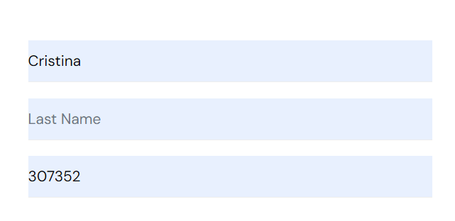

**Steps to reproduce**

**1. Accesam "https://www.saucedemo.com" cu userul 'problem_user'**

**(password: secret_sauce)**

**2. Selectam cu butonul ‘Add to cart’ cele 3 produse accesibile *\*Sauce Labs Backpack/ Sauce Labs Bike Light/ Sauce Labs Onesie*.**

**3. Accesam ‘Cosul de cumparaturi’ si apasam butonul ‘Checkout’.**

**4. Introducem date valide in cele 3 campuri. Campul ‘Last Name’ nu se poate completa.**

**5. Selectam butonul ‘Continue’.**

**6. Mesaj ‘Error: Last Name is required’.**

**Expected result**

**Acces pagina ‘Checkout Overview’.**

**Actual result**

**Nu se poate accesa pagina ‘Checkout Overview’.**

**Notes**